**Reflection**

1. In this lesson, you created your own *sound board app*. Give a brief description of it here. Describe its theme, if it has one, and what particular sounds (music or speeches) it plays. Click on Add Files at the bottom of the page to attach your **video** (or if you uploaded your video to youtube, use insert/youtube from the option above to embed your video in your portfolio page).

**Answer**

|  |
| --- |
| The soundboard I made has three sounds that are often heard with the theme of daily city life. The three sounds are a Muscle car, an Airplane landing and then Heavy Rain. |

2. Describe how you designed your app's UI. What components does it use?

**Answer**

|  |
| --- |
| For my apps UI I used buttons with images in them. The buttons activate the sounds that the users can use. The label up at the top will tell the user what sound they are listening to. |

3. Now that you've had some experience building apps in App Inventor, what do you think about ***programming***. Is it a creative activity? In what ways does it allow you to express yourself?

**Answer**

|  |
| --- |
| I really like programming, this is because it allows you to create whatever you want. It allows people to show of their ideas and express themselves in a very creative way. People can show of how they have created something or solved a problem because there is never just one wau for coding to do the same thing. |

Video Displaying the app

<https://youtu.be/18RSEFTbNnc>

Link To AIA file

<https://drive.google.com/open?id=1h5soVcnm8kLXrsMQUzXYJtke4d6Il23->

Link to APK

App Logo



QR code for app download



Screenshot Of Components

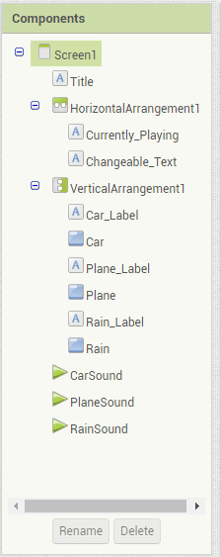

Screenshot Of Code

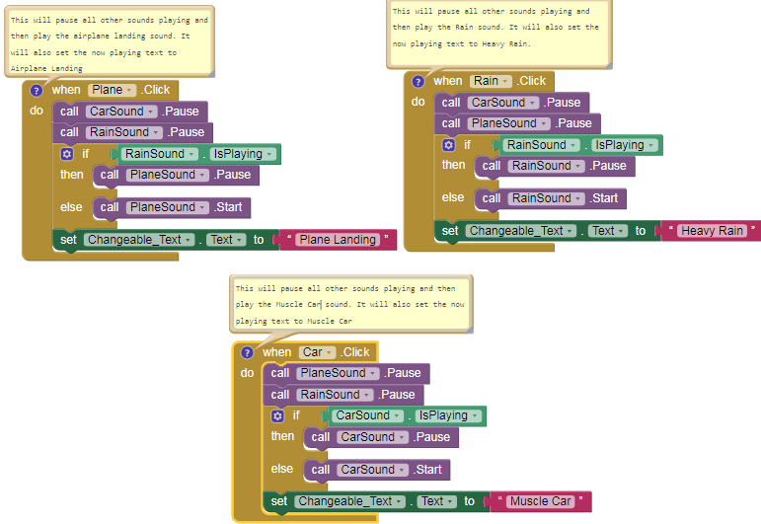

Screenshot Of UI

